FORECAST-BASED FINANCING TYPHOON EAP SIMULATION EXERCISES REPORT
September, 2019

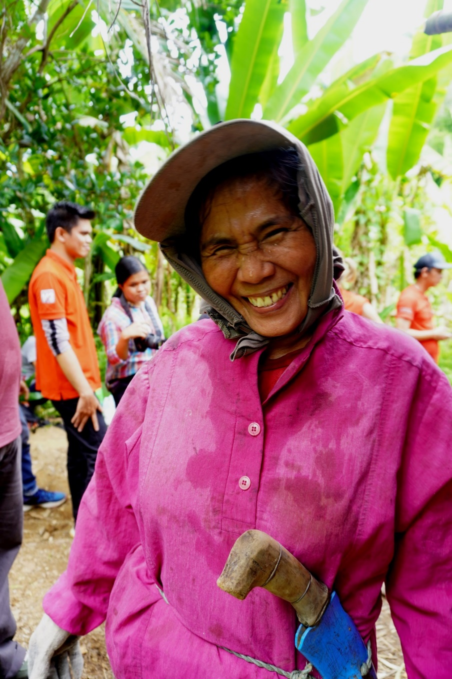
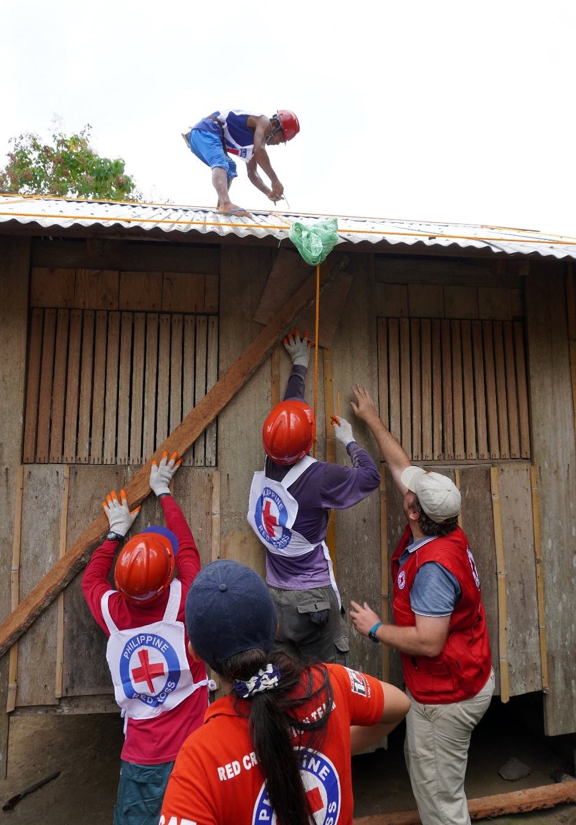




- INTRODUCTION

Forecast-based Financing (FbF) is an innovative mechanism considered to reverse the trend of an increasing number of natural disasters by addressing the gaps between forecasts and relief actions. To trial this mechanism, the German government has since 2013 pioneered several FbF pilot projects under the umbrella of their Action plan of the Federal Foreign Office (FFO) for humanitarian adaptation to climate change, in particular with the German Red Cross in Bangladesh, Peru and Mozambique.

In the Philippines, this project is being implemented from August 2017 to July 2020 and will support the PRC to reinforce its capacities in Disaster Reduction Risk Management, in particular through the planning and the activation of early response actions based on accurate forecasts and agreed early action protocols (EAPs). The overall objective is to contribute to the reduction of humanitarian consequences of extreme weather events on the affected population in high risk areas.

Chapters in most at-risk provinces have been prioritized and sensitized with FbF to be prepared for activation in case an extreme event happens. The FbF project for 2018 focused on piloting the implementation mechanism in 10 prioritized high-risk provinces nationwide. Key activities such as field visits, workshops, data gathering, community consultations, write shops, and simulations, led to a successful implementation and contributed to the drafting of Early Action Protocols (EAP) for Typhoon and Flooding. The first version of the EAPs covers 6 high risks provinces for Typhoon, and 4 high risks provinces for Flooding. Subsequently, in 2019, the FbF project is being rolled out in an additional 12 high risks provinces in order to achieve the goal of national scope, which will allow the PRC to be prepared for activation, in every part of the country, in case an extreme weather event happens. The project will be further expanded to additional provinces in 2020.

The Early Action Protocol (EAP) is a concrete and vital output of the implementation of FbF. It is a tool to guide the Philippines Red Cross (PRC) Society in implementing timely and effective anticipatory actions, when certain tropical cyclone forecasts show a high likelihood of severe impact in the country. It contains the step by step implementation of forecast based early actions. The EAP has 3 key elements; triggers, early actions, and finance. It explains what early actions will be taken, who takes the action, how, when, where, and with what funds as well the triggers defining the timing of such actions, turning the planned actions into reality. The EAPs are to be submitted to the Forecast based Action (FbA) by the DREF of the IFRC, before a possible activation.

For the PRC, the EAP focusing on Typhoon is soon to be submitted to the Forecast based Action (FbA) by the DREF of the IFRC, while the one on Flooding might not be ready before October 2019. Meanwhile, to ensure that the identified Early Actions can be implemented effectively, simulation exercises shall be conducted to test the planned mechanism.

Specific for typhoon, early actions identified are the following:
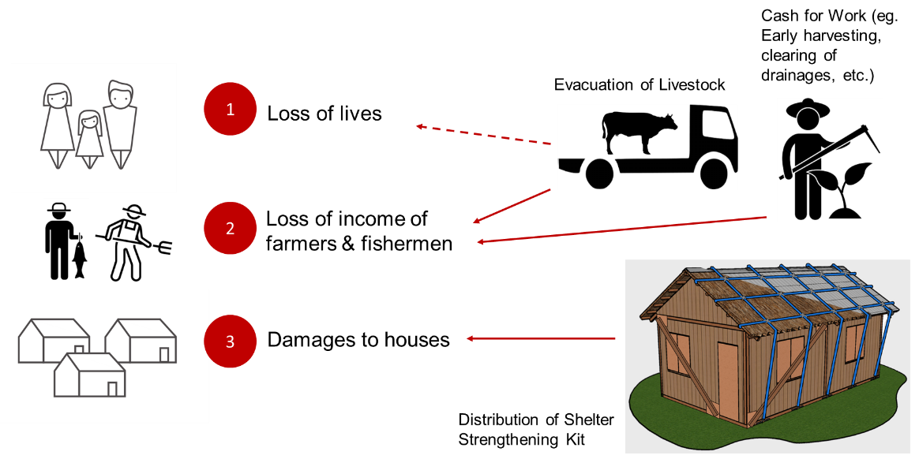

The simulation aims to practice, strengthen, and review the appropriateness of the EAP based on a given typhoon scenario. Specifically, this activity will look into the implementation of early action from the day the chapter receives the trigger until before the impact occurs. Through this activity, chapters will be familiarized with the action they need to implement once EAP has been activated. It will also allow, partners and stakeholders to understand what they need to do and open discussion on how PRC and LGUs activities can be complementing.

Simulation of the entire process was not possible due to time constraints and budget needed. Thus, only important and critical activities and early actions were tested.

- SCENARIO

Different typhoon scenarios were used for the 3 simulation exercises. Each depicting tropical cyclones with forecasted tracks, windspeed, gustiness, and specific areas that will acquire highest predicted damaged. Maps were sent to the chapters as a sample of actual maps that will be distributed to the chapters in times of actual activation. Those were snapshots from the 510 dashboard – impact-based forecasting. Below scenarios were the perfect ones having 5 - 4 days lead time. It should be noted that there will be possibility in the actual events that we will only have 4 - 3 days lead time.

Early Harvesting of Abaca through Cash for Work in Catanduanes

Day 1 (July 28th) – day -4 before landfall:

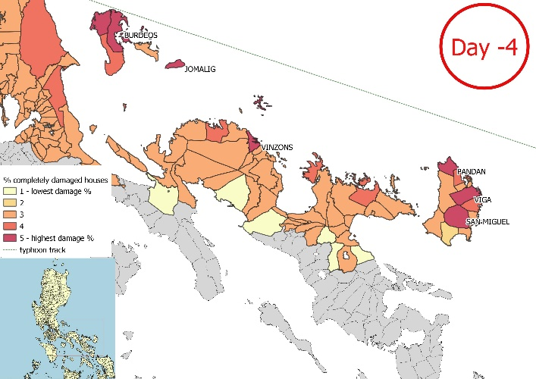
The tropical depression continued to intensified as it moved west northwest towards Eastern Luzon. It developed into Tropical Storm with maximum sustained winds of 80 kph near the center and gustiness of up to 100 kph.

Technical advisor, with assessment and monitoring of the 510 initiative of NlRC, advises DMS, which will then advise Opcen to send an “alert” warning to PRC: Tropical Storm with international name “Nari” has accelerated and intensified over the eastern part of the Philippine sea as it entered the eastern seaboard of the Philippine Area of Responsibility (PAR), and was named “Goring”. There is 40% probability that it will traverse and landfall in Bicol region, on 1st of August, 2019.

The tropical storm will start affecting Southern Luzon and Eastern Visayas beginning, Monday (July 29th). Still more than 3 days to go before effects will commence.

Day 2 (July 29th) – day -3 before landfall:

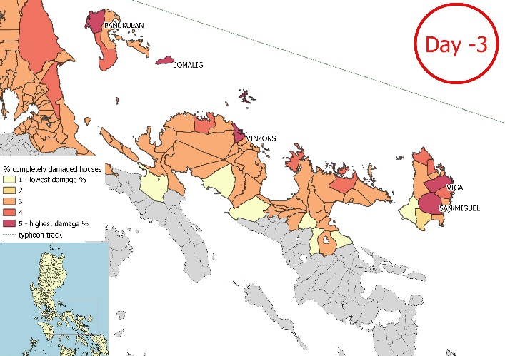
The tropical storm further intensified into a severe tropical storm (STS) with maximum sustained winds of up to 105 kph near the center and gustiness of up to 130 kph and it is forecasted too move West Northwest at 20 kph. It is now expected to make landfall in Bicol region as typhoon on Thursday, 1st of August, 2019.

Local government unit enforced the “no sailing policy” on all fishermen.

Technical advisor sends a “trigger” warning to PRC: The 3 days forecast for Tropical Storm “Goring” now indicates 80% probability that it will landfall in Bicol region, specifically in Catanduanes, in the night of Thursday, 1st of August, 2019. And the 510 statistical model is predicting that at least 3 municipalities will sustain total damage to at least 10% of the shelters. Municipalities of Viga a nd San Miguel is at particular risk due to its high vulnerability index and is being prioritized by PRC for its Early Action.

Distribution of Shelter Strengthening Kit and Cash for Work in Aurora

Day 1 (August 27th) – day -4 before landfall:

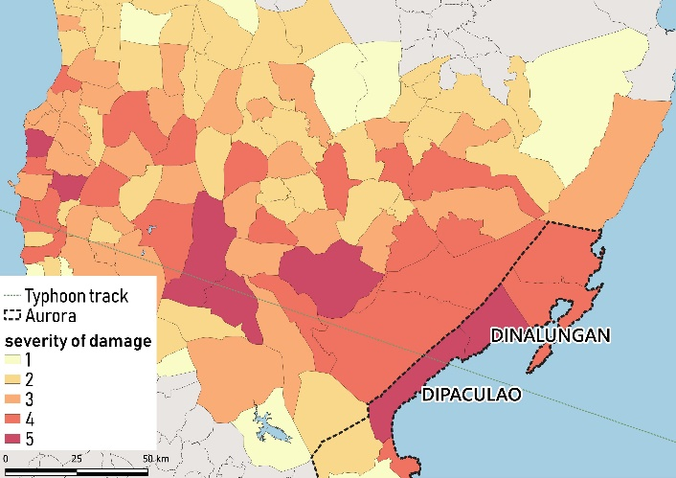
At 4:00 AM of August 26, the Low Pressure Area (LPA) in the East of Catarman, Northern Samar has developed into a Tropical Depression (TD) and was named "JUSTO" with maximum sustained winds of 45 kph and gustiness of 55 kph. TD JUSTO was forecasted to move west-northwest at 11 kph.

-4 Day

"JUSTO" slightly intensified as its maximum sustained winds increased to 55 kph and its gustiness increased to 70 kph and continued to move in a west-northwest direction at 10:00 AM and slightly accelerated at 13 kph as it moved closer to Bicol Region at 4:00 PM.

At 10:00 PM, "JUSTO" intensified into a Tropical Storm (TS) with maximum sustained winds of 65 kph and gustiness of 80 kph. Tropical Cyclone Warning Signal (TCWS) No. 01 was raised in Catanduanes, Camarines Sur, and Albay.

Technical advisor, with assessment and monitoring of the 510 initiative of NlRC, advises DMS, which will then advise Opcen to send an “alert” warning to PRC: Typhoon JUSTO with international name “Pacifica” has accelerated and intensified over the eastern part of the Philippine sea as it entered the eastern seaboard of the Philippine Area of Responsibility (PAR), and was named “JUSTO”. There is 40% probability that it will traverse and landfall in the region of Central Luzon, on 31st of August, 2019 (Saturday)

The typhoon will start affecting Southern Luzon beginning, Wednesday (August 28th). Still more than 3 days to go before effects will commence.
Day 2 (August 28th) – day -3 before landfall:

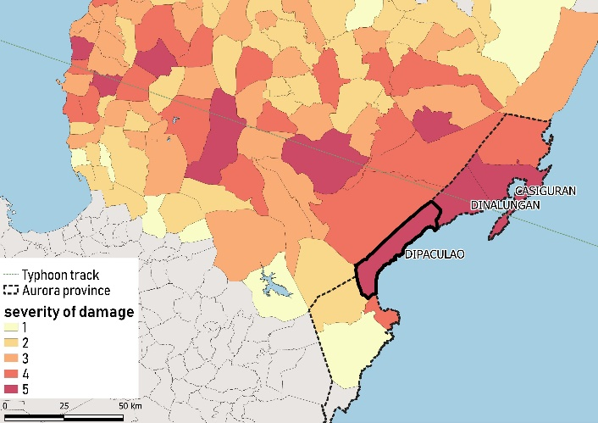
At 4:00 AM, TS JUSTO was at 335 km east of Virac, Catanduanes and further intensified with maximum sustained winds of 75 kph and gustiness of 95 kph as it continued to move in a west-northwest direction.

-3 Day

TCWS No. 02 is raised in Catanduanes and TCWS No. 01 in Polilio Island, Aurora, Quezon, Camarines Norte, Camarines Sur, Albay, and Sorsogon.

In the evening, JUSTO intensified into a Typhoon as it continues to threaten the province of Catanduanes. At 10:00 PM, it was located at 160 km East Northeast of Virac, Catanduanes with maximum sustained winds of up to 120 kph near the center and gustiness of up to 150 kph while moving West Northwest at 9 kph.

Technical advisor sends a “trigger” warning to PRC: The 3 days forecast for Typhoon JUSTO now indicates 80% probability that it will landfall in Central Luzon, specifically in Aurora, in the morning of Saturday, 31st of August, 2019. And the 510 statistical model is predicting that at least 3 municipalities will sustain total damage to at least 10% of the shelters. Municipality of Dipaculao is at particular risk due to its high vulnerability index and is being prioritized by PRC for its Early Action.

Community Evacuation with Livestock in Davao Oriental

Day 1 (September 3rd) – day -4 before the landfall:

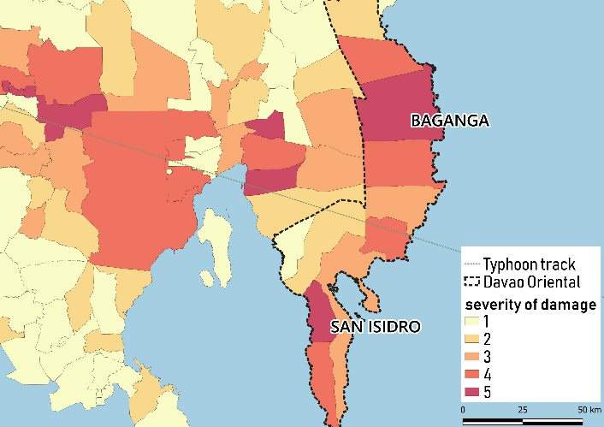
0800: The center of severe tropical storm Marilyn was estimated based on satellite and surface data at 1,040 km East of the Eastern border of the PAR with maximum winds of 95 kph near the center and gustiness up to 120 kph. It is forecasted to move west at 20 kph
- 4 Day
1400: Severe tropical storm Marilyn was over the pacific ocean and had slightly intensified and tracked west southwest at an average speed of 25 kph for the past 24 hours.
Technical advisor, with assessment and monitoring of the 510 initiative of NlRC, advises DMS, which will then advise Opcen to send an “alert” warning to PRC: Typhoon MARILYN with international name “In-fa” has accelerated and will intensified over the eastern part of the Philippine sea as it entered the eastern seaboard of the Philippine Area of Responsibility (PAR), and was named “MARILYN”. There is 40% probability that it will traverse and landfall in the region of Davao, on 7th of September, 2019 (Saturday)

The typhoon will start affecting eastern Mindanao beginning, Wednesday (September 4th). Still more than 3 days to go before effects will commence.

Day 2 (September 4th) – day -3 before the landfall:

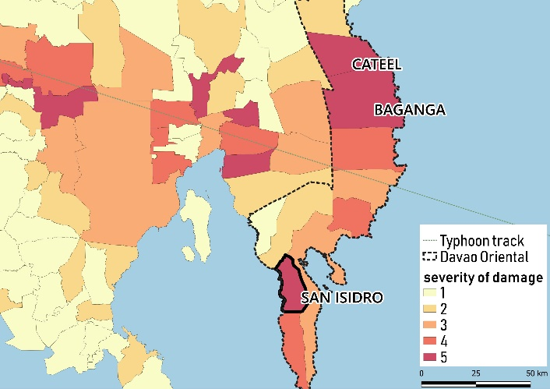
1000: Severe tropical storm intensified into typhoon and is expecting to enter the PAR this evening
- 3 Day
The location of center is at 1,110 km east southeast of Hinatuan, Surigao del Sur. With maximum sustained winds of 140 kph near the center and gustiness of up to 185 kph
1800: Typhoon Marilyn has accelerated and entered PAR
The location of center is at 810 km southeast of Hinatuan, Surigao del Sur. With maximum sustained winds of 160 kph near the center and gustiness of up to 195 kph
2000: TCWS No. 3 was raised in Surigao del Sur, Surigao del Norte, Siargao, Dinagat, Agusan del Norte, Agusan del Sur, Davao Oriental, Davao del Norte, Compostela Valley, Bukidnon, Misamis Oriental, Camiguin
Technical advisor sends a “trigger” warning to PRC: The 3 days forecast for Typhoon Marilyn now indicates 80% probability that it will landfall in Davao region, specifically in Davao Oriental, in the morning of Saturday, 7th of September, 2019. And the 510 statistical model is predicting that at least 3 municipalities will sustain total damage to at least 10% of the shelters. Municipality of San Isidro is at particular risk due to its high vulnerability index and is being prioritized by PRC for its Early Action.

- METHODOLOGY

Various methodologies were used in each simulation to test different scenarios and activities.

Early Harvesting of Abaca through Cash for Work in Catanduanes
- Given the 4 days lead time, the simulation exercise started with the chapter receiving the alert message. Once received, the chapter demonstrated its preparedness activities such as the following:
  - Activate all staff and chapter-based volunteers
  - Call for a meeting. Chapter Service Representative (CSR) for DMS presented the following:
    - Alert message received from OpCen
    - Checking of chapter resources
    - Possible mobilization and deployment
    - Availability of volunteers: activation of RC143
    - Present team composition available in chapter: Health and welfare, Evacuation, Assessment, WASH and Logistics, Search and Rescue, Ambulance, Finance and Administrative Aid
    - Reminders for all in case of emergency: prepare necessary supplies and equipment, strategy plans for respective teams, safety and preparations for the families
    - Reminders for activated volunteers: specific tasks per team*
  - Chapter did coordinate with the provincial LGU to inform of the possible activation in case trigger will be reached
  - At the end of the day, chapter preparedness activities were reported to NHQ
*In the scenario presented by the chapter, FbF was not treated as a separate activity, rather they integrated it in the assessment. It means that those staff and volunteers who will be assigned in the assessment team, will do tasks also for forecast-based early actions.

Additional preparation conducted by the chapter, specific for FbF were:
- Rechecking of shortlisted areas and pre-screened households
- Preparations of documents: attendance, acknowledgement receipt, service contract, etc.
- Fund preparation and withdrawal
- Coordination for vehicles for transportation
- Given the 3 days lead time, chapter received trigger message, as shown in the previously presented scenario. Once received, the chapter alerted PDRRMO, finalized barangays, arranged logistics, and travel to the targeted areas.
  - Courtesy call was made in the Municipal LGU
  - Courtesy call was also made in the Barangay LGU. After which, barangay activities started:
    - Meeting with Barangay Committee and brief discussion of the following:
      - Introduction to Red Cross, 7 principles, and major services
      - Purpose, roles, and responsibilities of barangay committee
      - FbF project: intended early action
      - Beneficiary criteria: inclusion and exclusion
Vulnerability criteria for priority households

INCLUSION: abaca landowner with ≤ 2 hectares of cultivable land; households with disabled or senior citizens member; solo parent; household with ≥ 5 children; house made of light materials; family with monthly income of ≤ Php10,000.00

EXCLUSION: government employees; abaca landowners with ≥ 3 hectares; households with business; retailers and traders; households receiving remittance abroad
      - Work description
      - Forms required: ID / Bio data, Attendance, Acknowledgement Receipt, and Service Contract
    - Once beneficiary list has been reviewed, validated, and finalized, beneficiaries were called for an orientation. Same topics were discussed as above. Then, works started.

Distribution of Shelter Strengthening Kit and Cash for Work in Aurora

- The activity started with a tabletop exercise. Scenarios were presented from -4 day until 0 day (impact occurrence). With every scenario, the chapter demonstrated, using the map and miniature resources, the chapter activities.
- This exercise stimulated questions from the participants and clarified some concerns regarding implementing forecast-based early actions.
- The following day was simulated as the -3 day. It started with the courtesy call to the Municipal Mayor. Then, barangay activities begun.
  - Barangay validation was convened
  - Lists of beneficiaries and workers were reviewed and finalized, through the inclusion and exclusion criteria
  - Beneficiaries were called and gathered for an orientation:
    - RCRC Movement & PRC Services
    - Introduction of barangay validation committee
    - Presentation of selection criteria
    - FbF Overview (including assistance to be received)
    - Process of distribution
    - Orientation to SSK IEC
  - Kits were distributed
  - Strengthening of shelters started.
  - Pay-out for the workers after completion of works
- At the end of the day, chapter preparedness activities were reported to NHQ

Community Evacuation with Livestock in Davao Oriental

- In this simulation, -4 day and -3 day were compressed in only 1 day. This was an example of a non-perfect scenario, with only 4-3 days of a lead time.
- Given the 4 days lead time, the simulation exercise started with the chapter receiving the alert message. Once received, the chapter demonstrated its preparedness activities such as the following:
  - Activate all staff and chapter-based volunteers
  - Call for a meeting, which was presided by the Chapter Administrator:
    - She presented the alert message received from OpCen
    - Checking of chapter resources, including blood supplies, non-food and food items, vehicles, and manpower (staff and volunteers)
    - Possible mobilization and deployment
    - Reminders for activated volunteers: specific tasks per team*
  - Chapter did coordinate with the provincial LGU to inform of the possible activation in case trigger will be reached. Also, assuming the provincial LGU received similar information from PAGASA, chapter attended the Pre-Disaster Risks Assessment Meeting (PDRA) held in Provincial Operation Center. Along with PRC, other agencies were present as well: Provincial Disaster Risk Reduction and Management Office (PDRRMO), PDRRMO – Operation Center, Provincial Social Welfare and Development Office (PSWDO), Provincial Veterinary Office (PVO), Provincial Agriculture Office (PAGRO), Department of Agriculture (DA), Bureau of Fire and Protection (BFP), Provincial Engineering Office (PEO), Department of Interior and Local Government (DILG), Provincial Crop Insurance Corporation (PCIC).
  - On this meeting, below were discussed:
    - Situation overview: track and strength of tropical cyclone
    - Mapping and updating of existing resources from different provincial agencies
    - Review of past events and identifying high risks areas: as per their records, last June 29, 2019 they experienced local thunderstorm that killed a number of livestock in Municipality of San Isidro. Thus,
    - Coordination with Municipality of San Isidro, which identified as high risks
Additional preparation conducted by the chapter, specific for FbF were:
- Rechecking of shortlisted areas and pre-screened households
- Preparations of documents: attendance, acknowledgement receipt, service contract, etc.
- Fund preparation and withdrawal
- Coordination for vehicles for transportation
- Given the 3 days lead time, chapter received trigger message, as shown in the previously presented scenario. Once received, and assuming the provincial LGU also received similar information from PAGASA, the chapter again alerted PDRRMO, finalized barangays, arranged logistics, and travel to the targeted areas.
  - Courtesy call was made in the Barangay LGU. After which, barangay activities started:
    - Meeting with Barangay Committee and brief discussion of the following:
      - Introduction to Red Cross, 7 principles, and major services
      - Purpose, roles, and responsibilities of barangay committee
      - FbF project: intended early action
      - Review and finalize lists of beneficiaries. Since the simulation was community evacuation with livestock, beneficiaries were chosen based on their geographical location in the barangays, those in low lying areas and near the coast were prioritized; those households who have been affected by the previous disaster; those vulnerable households especially member of 4Ps; also, those who owns backyard livestock were encouraged to bring their livestock in the designated evacuation area for animals.
      - Different teams were formed in the barangay such as Welfare, Animal evacuation, Food,
    - As soon as meeting was finished, animal evacuation team built the fence.
- Given the 2 days lead time, the barangay already did the community evacuation with livestock. Every households brought their Go-Bag and all went to the designated evacuation site. Others, with livestock, brought their animals in the designated evacuation area for livestock.
- At the end of the day, chapter preparedness activities were reported to NHQ

- OUTPUT OF THE SIMULATIONS


Early Harvesting of Abaca through Cash for Work in Catanduanes

Province: CATANDUANES
Municipalities: VIGA and SAN MIGUEL
Barangays: VILLA AURORA and TOBREHON
Beneficiaries: 30 workers (farmers / fishermen) per 1 barangay (a total of 60 workers for 2 barangays)
Early Action:
- Tumbling/Cutting of Abaca Tree: ≤ 5 seconds
- Tuxying: ≤ 10 minutes
- Stripping: ≤ 5 minutes
*in 1 hour, there were an average of 250 trees cut by 30 workers

Cash assistance: after completion of works, each worker received Php500.00 / day

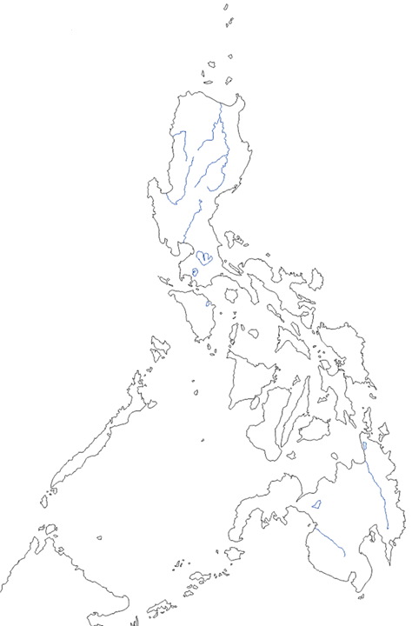


Distribution of Shelter Strengthening Kit and Cash for Work in Aurora

Province: AURORA
Municipality: DIPACULAO
Barangays: BORLONGAN, DIANED, DINADIAWAN, and CALAOCAN
Beneficiaries: 8 beneficiary households (for SSK) and 5 beneficiary workers (for cash for work) per 1 barangay (a total of 32 beneficiary households and 20 beneficiary workers for 2 barangays)
Early Action:
- Distribution of shelter strengthening kit (SSK)
- Strengthening of weak shelters
*1 shelter can be strengthened in an average of 1 hour with 1 team of workers (5 members: 2 skilled + 3 unskilled workers)

Cash assistance: after completion of works, a team will receive a total of Php2,050.00 for strengthening 8 shelters
- Php500.00 = skilled workers
- Php350.00 = unskilled workers

Shelter Strengthening Kit (SSK)

Roofing Items
10 mm nylon rope (200 m) – 1 roll
3” CWN – 2 kilos
4” CWN – 1 kilo
12 mm iron rebar cleats – 12 pcs
GI tie wire #16 – 1 kilo
Hammer – 1 pc
Saw – 1 pc
Steel tape – 1 pc
Pliers – 1 pc

Walling Items
2”x4”x10” coco lumber – 5 pcs
¾” marine plywood – 0.5 pc
3” CWN – 2 kilos

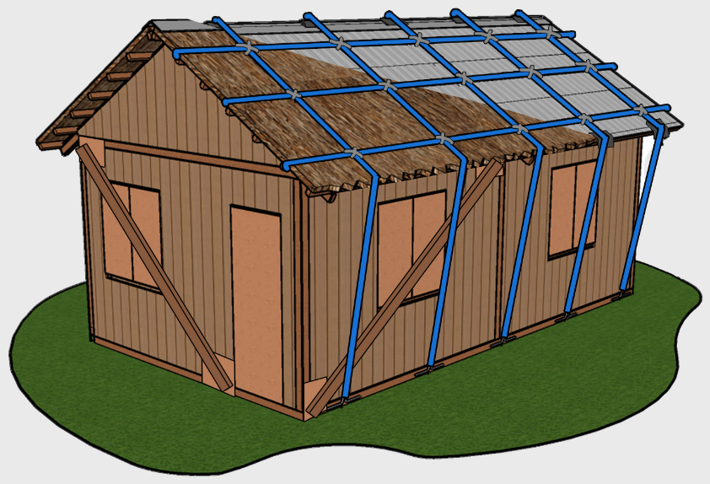



Community Evacuation with Livestock in Davao Oriental

Province: DAVAO ORIENTAL
Municipality: SAN ISIDRO
Barangays: CABALEON and LA UNION
Beneficiaries:
- a total of 88 families and at least 350 individuals evacuated
- with at least 31 carabaos, 9 cows, 5 pigs, 16 goats, and some chickens
Early Action:
- Support in evacuation of livestock: setting up fence
*clearing of areas and putting up a fence of 10m x 10m was completed in half day of work, with 10 workers in 1 barangay

Cash assistance: after completion of works, each worker received Php500.00 / day

This simulation exercise was in collaboration of the following agencies which provided different support:
- PSWDO: food packs for the evacuees
- PVO: forage, deworming, and vitamins for the ruminants
- BFP: water for the animals
- PEO: 2 units of truck with ramps (only PRC will cover fuel and allowance/food for the driver and assistants)
- PCIC: recorded animals for insurance coverage
- PRC: hotmeals for the evacuees

- LEARNINGS FOR THE EARLY ACTIONS TESTED

Debriefing was made after the simulation exercises, few points taken were as follows:

Early Harvesting of Abaca through Cash for Work in Catanduanes

Specific for this simulation, each step in the implementation process for chapter were reviewed, and participants feedback were noted as below:

- Alert message
  - Should be simplified for volunteers and RC 143
  - Should contain predicted track of typhoon and rainfall map
- Chapter meeting / orientation of volunteers
  - Structure for disasters: organized in advance, including FbF
  - Good number of active volunteers: 1 province = 30 barangay (30 – 60 volunteers in every barangay)
  - Important to recruit more volunteers for implementation of early actions
  - Distribution of volunteers per service / Activation of RCAT according to task
  - Possibility of volunteers’ augmentation from neighboring chapters
- Screening and prioritization of LGU / courtesy call / Prescreen farmers
  - Important to establish a strong partnership (coordination & communication) with LGU/ barangay
  - Proper dissemination/ communication from chapter to the barangay and vice versa
  - Prioritization of targeted municipality/barangay according to accessibility/ number of workers for transportation
  - Equal distribution of workers per land
  - List of beneficiaries should be confirmed in advance and give them the orientation, then on day -4 they just have to be confirmed
  - Discuss more on the process and criteria on the prioritization of beneficiaries from among those identified as qualified
- Preparation of forms / activation of PRC 143
  - Simplified and not too many forms
  - Involvement of RC 143 on day -4
- Trigger / Final list of LGUs
  - Alert message on the trigger should be disseminated as soon as the relevant weather bulletin is issued by PAGASA to give more time to travel to the remote sites targeted
  - 510 will inform which municipality will be affected, then the chapter decides which barangays will be covered
  - Chapter should share with NHQ on weather forecast and real time observation in the field
  - If possible, to include:
    - Activation chronogram for the chapters
    - Color code on day -3 for Activation or Deactivation - need to check with the DMS Response SOP
  - Assigned volunteers for specific barangays to validate the final listing of beneficiaries
- Call LGU / Volunteers Mobilization
  - Orient and train volunteers on FbF – possibility of training package
  - Need transport for volunteers for covering ≥ 15 barangays
  - There is a need to rent vehicle - one vehicle per municipality
- Validation of farms that will be cleared
  - Consent and cooperation of land owners are needed
  - Farms that are closer/ more accessible should be prioritized
  - Geo-tagging of farms to be cleared (there are no maps available yet)
    - Should be done during prescreening
    - Should consider data gathered by PDRRMO
- Registration and Orientation of workers (cash for work)
  - Workers have to be pre-identified: compilation of bio-data should be done during/after beneficiaries’ registration, and reviewed before activation of EAP
  - Registration of workers: should be prepared with photocopies in advance
  - Consider brief orientation about RC: maybe a video in local language (10 – 15 min)
  - Weather condition and risk must be discussed during orientation
  - Challenge could be the availability of workers - are they still willing to work in a real scenario?
  - The workers concerns:
    - Their families: prefer securing their HH and family first
    - Might be at the evacuation center with the family
    - Risk of landslides
  - Possible recommendation:
    - Explore working with abaca associations or cooperatives
- Cutting of abaca trees
  - Should be skilled workers
  - Include non-abacaleros (e.g. fishermen), but train them
  - Basis for the estimation of output per worker is relevant
  - Mixed approach: cutting and trimming trees - keep cut trees covered under shade, so they can process them up to 2 weeks later
- Pay out of workers
  - Should be fast
  - Flexible requirements: if no ID presented, bio-date can work but there should be counter signed by the barangay officials
  - Prepare stamp pad
Other Recommendations:
- It is important to communicate in local language
- Early action should include trimming of trees, and also the option of cutting and just covering the trees
- Clarify that FbF is covering only before typhoon, not afterwards - if the stripping has to be done later, who pays for it?
- Meeting with the land owners to explain or even to sign a legal document to make sure what actions are covered by FbF

Distribution of Shelter Strengthening Kit and Cash for Work in Aurora

Participants were asked for positive and negative key takeaways for the simulations, summary are as follows:

POSITIVE KEY TAKE AWAYS:
- The sole purpose of SSK was concretely demonstrated during the simulation, which was to lessen the impact of the typhoon in the shelters.
- Strong manpower in the form of volunteers was very visible during the simulation. Chapter based volunteers were adequate. Also, chapter mobilized an external volunteer group which made the implementation easier and faster.
- There has been a positive and strong support from the Provincial, Municipal, and Barangay LGUs. They accepted the concept and provide necessary supports especially in logistics such as trucks.
- Selection of workers were good. They easily grasp the SSK technique and also were able to adjust the technique depending on the type and style of the shelter.
- Proper orientation to the beneficiaries and workers were noted. Less time was consumed, compare to previous simulation (in Catanduanes), which was better, and allowed more time in strengthening of shelters.
- SSK items were better compared to previous. With the change in iron rebar cleats, compare to wood cleats, it saves more time in installation, especially that it has been distributed pre-fabricated already.
- Team of 5 workers, with the combination of skilled and unskilled were adequate and good.

NEGATIVE KEY TAKE AWAYS:
- There has been late delivery of supplies, mainly because of coco lumber. This led to delayed in work.
- In some barangays, distribution of SSK has not been very organized.
- Lack of information dissemination to the beneficiaries and communities, thus, some beneficiaries were not aware of the program.
- Weak involvement of Barangay Committee to the activities. They were less visible and not well engaged.
- SSK IEC is too technical and not written in own dialect.
- Criteria for beneficiary selection has not strictly followed. Some shelters have been selected even it fall under “not applicable for SSK”.
- Local resources were overlooked, such as nets, and other kind of lumber.

MAIN RESULTS:
- Selection of shelters is crucial, since the kit is intended for strengthening weak shelters and does not work for repairing dilapidated one.
- Orientation to the workers of the SSK design is necessary but should be clear that it is not limited to that, since they can do more technique (in addition to the guide) and use other readily available local materials, that will ensure further strengthening of the shelters.
- It will be good to do community orientation of the SSK, so for those who will not receive SSK, they can at least have the knowledge on the technique in strengthening their shelters.
- Beneficiaries (of the SSK) should be aware and involve in installation of SSK, to promote ownership and make sure they can replicate it when same event happens in the future.
- There should be less technical IEC, written in local dialect, for orienting workers, beneficiaries, and the community.
- Barangay committee should be well established and ensure engagement in all field activities.
- Availability of materials, especially lumber should be ensured. The team shall do market analysis and explore engaging into a memorandum of agreement / understanding with the local suppliers to ensure availability of stocks, in given short lead time.

Community Evacuation with Livestock in Davao Oriental

Participants were asked to lists things for improvement, questions, and learnings from the simulation exercise.

IMPROVEMENT
- There should be standard design for livestock evacuation area: size, segregation, materials,
- There should be an implementing rules and regulations (IRR) / guideline / standard protocol for evacuation of livestock.
- There should be training on the following: proper animal handling, profiling, recording, and provision of basic services for livestock.
- Consider other type of tagging.
- Consider waste management for evacuation site, guidelines and protocol.
- Involvement of local colleges and state university should be explored.

QUESTIONS
- What are the criteria to identify safe area for livestock evacuation center? What is the standard design, lay-out, water, food, groupings of animals?
- Who is responsible for the security of livestock in the evacuation area?
- Can we include livestock evacuation in the BDRRM plan?
- What is the proper way of recording/reporting during livestock evacuation?
- Hoe about insurance?

LEARNINGS
- Mostly they learned on the concept of livestock evacuation: proper area, design, segregation, tagging, feeding, etc.
- Barangay officials became knowledgeable on the importance of livestock evacuation and acquire minimum information on how to execute it.
- Engagement of community was very visible. They really took part and owned the activity. Community acceptance and appreciation were seen and felt all throughout the activity.
- In the basic camp management training, there should a module on livestock evacuation.
- Evacuation of livestock can be included in the BDRRM plan so budget can be allocated.

MAIN RESULTS:
- It’s good that evacuation of livestock has been tested in actual simulation exercise. As of this moment, though there is RA 8485 Animal Welfare Act of 1998, still there is no concrete document stating the guidelines or standard protocol for livestock evacuation. No specific design, lay-out, tagging, or any system established yet for livestock evacuation, only we can set parameters such as it should be in open and safe areas, free from hazards; different species should be separated; there should be adequate supply of water and food for the animals; and they should not be tied down and should roam freely.
- There is a need to collect information and come up into a guideline / standard protocol for livestock evacuation.
- It can be part of camp management, and whoever designated as the camp manager shall be the one to assign a team for supporting livestock evacuation.
- Integration to DRRM plan (for both barangay and municipality) is feasible, and provincial agencies (in case of Davao Oriental), is ready and prepared to augment any assistance.

Involving the provinces of Camarines Norte, Camarines Sur, Catanduanes, North Samar, East Samar and Samar for the typhoon EAP, and the provinces of Capiz, Agusan Norte, Agusan Sur and Compostela Valley for the flood EAP.
FbF is at this stage involving the additional provinces of Albay, Aurora, Cagayan, Cebu, Davao Oriental, Isabela, Leyte, Southern Leyte, Masbate, Sorsogon, Surigao del Sur and Surigao del Norte for the typhoon EAP, and the provinces of Agusan Norte, Agusan Sur, Cagayan, and Isabela for the flood EAP and a nationwide EAP for drought.
https://www.forecast-based-financing.org/fund/

